## Overall Summary:

* Year = 2018
  + Why 2018? Q2’s data is only provided in this year, so we had to stick to it
  + Caused problems of small dataset but at least it is consistent
* Theme = Civil and Political Rights (Q1, Q3), with focus to People at Risk (Q2), in countries around the globe
  + Why this theme? These rights and these groups of peop;e are especially relevant in today’s political climate
  + Why around the globe? Data is from around the world, it is good to gain a better understanding of the world, not just the US or any specific country
* Q1 - broad: comparing whole political systems and government types around the globe
* Q2 - specific: comparing specific groups/communities of people
  + Mention if this is country specific
* Q3 - bringing together Q1 (broad, about safety from the state) and Q2 (specific, about rights to assembly aka union) to check for any correlation or external factor

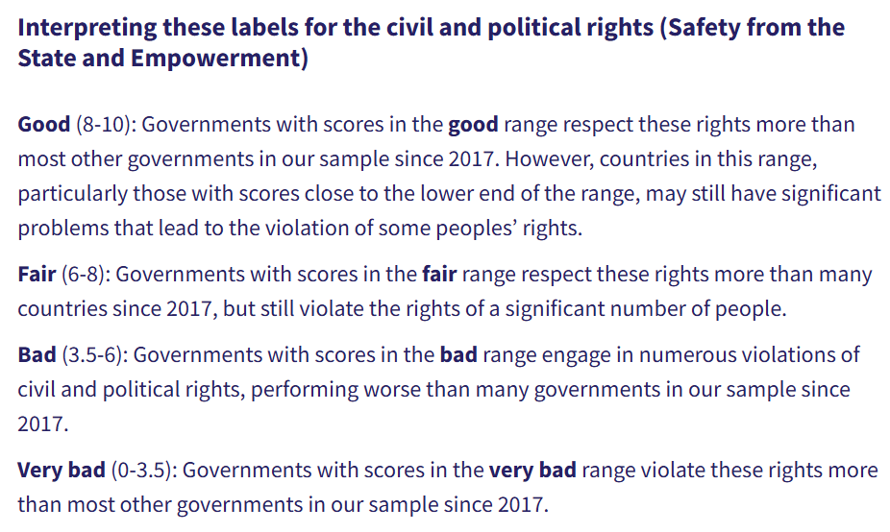

* More about each question below:

## Question 1: Compare various countries’ rights to death penalty execution (dpex) and the right to participate in government. **dpex and polplart**, to their right to freedom from torture and ill treatment **(tort)** in **HRMI Civil and Political Rights (CPR) dataset.**

**Broad Question: What patterns exist between different civil and political rights across countries?**

**Narrow Question:What variations exist among countries in 2018 in promoting political participation, providing death penalty protections, and preventing torture?**

* Variables used:
  + **year(2018)**
  + **country**
  + **dpex-** Right to freedom from death penalty execution
  + **poplart-Right** to participate in government
  + **Tort**-Right to freedom from torture and ill-treatment
* Plots with 3-layers(x axis =**polpart_mean**, y axis = **dpex_mean**, size of dot = **tort_mean)**
* Results:
  + positive correlation found between the right to participate in government and the right to freedom from death penalty execution
  + As both DPEX and POLPART increase, the size of the variable "TORT-Right to Freedom from Torture and Ill-Treatment" also increases, suggesting a relationship between greater rights to participate in government and protection from the death penalty with stronger rights against torture and ill-treatment.
* Summary: Based on our analysis of the 2018 data for the Civil and Political Rights dataset, our scatterplot shows the relationship between the right to participate in government and the right to freedom from the death penalty across different countries. Every country is represented by a circle, and the size and color reflects the level of freedom from torture, which the lighter and larger circles indicating greater freedom from torture. The countries with higher values on the x- and y-axes have stronger protections for political participation and freedom from the death penalty. This visualization showcases which countries rank higher in political and deth penalty rights and how torture levels vary between them.

**Q1:**

**Code for all options (includes importing libraries, loading dataset, and filtering columns to the year 2018)**

**import pandas as pd**

**import matplotlib.pyplot as plt**

**import plotly.graph_objects as go**

**cprq1 = pd.read_csv("C:/Users/Daisy/OneDrive - Emory/Desktop/QTM 151/HRMI_Data_Download_2024_release/HRMI_Data_Download_2024.6.20/csv files/cpr.csv") *# Updated file path (will need to be changed individually to work for each person’s code)***

**print(cprq1.columns)**

**cprq1.head()**

**cpr_2018 = cprq1[cprq1['year'] == 2018]**

**cpr_2018.head()**

**columns_of_interest = ['country', 'year', 'polpart_mean', 'polpart_sd', 'polpart_lo', 'polpart_hi',**

**'dpex_mean', 'dpex_sd', 'dpex_lo', 'dpex_hi', 'tort_mean', 'tort_sd', 'tort_lo', 'tort_hi']**

**cpr_q1_2018_filtered = cpr_2018[columns_of_interest]**

**cpr_q1_2018_filtered.head()**

**cpr_q1_2018_filtered**

**Option 1: Interactive plot color based on tort_mean**

***# Interactive scatter plot with color based on tort_mean***

**fig = go.Figure()**

**fig.add_trace(go.Scatter(**

**x=cpr_q1_2018_filtered["polpart_mean"],**

**y=cpr_q1_2018_filtered["dpex_mean"],**

**mode='markers',**

**text=cpr_q1_2018_filtered['country'],**

**marker=dict(**

**size=cpr_q1_2018_filtered['tort_mean'] * 7,**

**color=cpr_q1_2018_filtered['tort_mean'],**

**colorscale='Viridis',**

**showscale=True,**

**colorbar=dict(**

**title='Mean Torture Level',**

**titleside='right',**

**tickvals=[cpr_q1_2018_filtered['tort_mean'].min(),**

**cpr_q1_2018_filtered['tort_mean'].max()],**

**ticktext=['Low', 'High'] *# label bottom "Low" and top "High"***

**),**

**opacity=0.6**

**),**

**hovertemplate='<b>Country:</b> %{text}<br>' +**

**'<b>Right to Participate in Government:</b> %{x}<br>' +**

**'<b>Freedom from Death Penalty:</b> %{y}<br>' +**

**'<b>Mean Torture Score:</b> %{marker.color}<extra></extra>'**

**))**

***# X and Y axis labels and title***

**fig.update_layout(**

**title={**

**'text': 'Government Participation vs Freedom from Death Penalty and Torture (2018)<br><sup>Higher x-values mean stronger rights; Higher y-values mean stronger freedom from death penalty<br><sup> Lighter color indicates higher torture mean score',**

**'y':0.95,**

**'x':0.5,**

**'xanchor': 'center',**

**'yanchor': 'top'**

**},**

**xaxis=dict(**

**title='Right to Participate in Government (Mean Score)',**

**title_font=dict(size=18),**

**tickfont=dict(size=12)**

**),**

**yaxis=dict(**

**title='Freedom from Death Penalty (Mean Score)',**

**title_font=dict(size=16),**

**tickfont=dict(size=12)**

**),**

**width=1000,**

**height=600,**

**template='plotly_white'**

**)**

**fig.write_html("C:/Users/Daisy/OneDrive - Emory/Desktop/QTM 151/HRMI_Data_Download_2024_release/HRMI_Data_Download_2024.6.20/csv files/cpr_interactive_plot.html")**

**fig.show()**

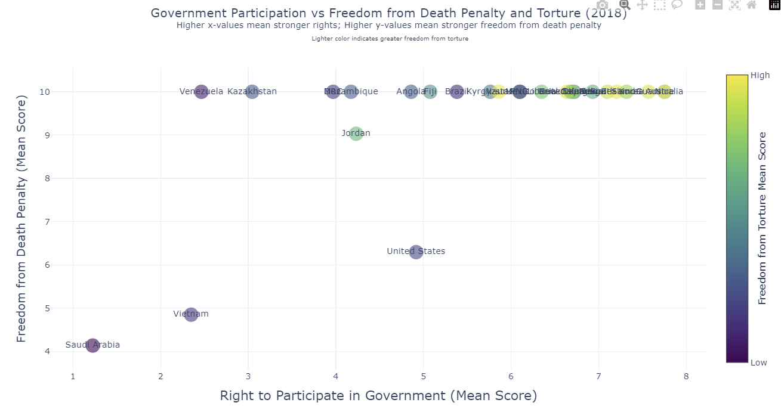

**Option 2: Interactive Scatterplot categorized by country**

**countries = sorted(cpr_q1_2018_filtered['country'].unique())**

***# one trace per country***

**fig = go.Figure()**

**for country in countries:**

**df_subset = cpr_q1_2018_filtered[cpr_q1_2018_filtered['country'] == country]**

**fig.add_trace(go.Scatter(**

**x=df_subset["polpart_mean"],**

**y=df_subset["dpex_mean"],**

**mode='markers',**

**name=country,**

**text=df_subset['country'],**

**marker=dict(**

**size=df_subset['tort_mean'] * 7,**

**color=df_subset['tort_mean'],**

**colorscale='Viridis',**

**showscale=False, *# one global colorbar***

**opacity=0.7**

**),**

**visible=True *# control visibility w/ dropdown***

**))**

***# Dropdown buttons***

**dropdown_buttons = [**

**dict(label="All",**

**method="update",**

**args=[{"visible": [True] * len(countries)},**

**{"title": "Government Participation vs Freedom from Death Penalty and Torture (2018)"}])**

**]**

**for i, country in enumerate(countries):**

**visibility = [j == i for j in range(len(countries))]**

**dropdown_buttons.append(**

**dict(label=country,**

**method="update",**

**args=[{"visible": visibility},**

**{"title": f"{country}: Participation vs Death Penalty Freedom"}])**

**)**

***# Layout***

**fig.update_layout(**

**updatemenus=[**

**dict(**

**active=0,**

**buttons=dropdown_buttons,**

**direction="down",**

**x=1.12,**

**xanchor="left",**

**y=1.15,**

**yanchor="top"**

**)**

**],**

**title={**

**'text': 'Government Participation vs Freedom from Death Penalty and Torture (2018)<br><sup>Higher scores mean stronger rights; bigger circle=greater freedom from torture.</sup>',**

**'y':0.95,**

**'x':0.5,**

**'xanchor': 'center',**

**'yanchor': 'top'**

**},**

**xaxis_title="Right to Participate in Government (Mean Score)",**

**yaxis_title="Freedom from Death Penalty (Mean Score)",**

**xaxis_tickangle=0,**

**width=1000,**

**height=600,**

**template="plotly_white"**

**)**

***# Add the single colorbar (legend) separately***

**fig.update_layout(**

**coloraxis_colorbar=dict(**

**title='Mean Torture Level',**

**tickvals=[cpr_q1_2018_filtered['tort_mean'].min(), cpr_q1_2018_filtered['tort_mean'].max()],**

**ticktext=['Low', 'High']**

**)**

**)**

**fig.show()**

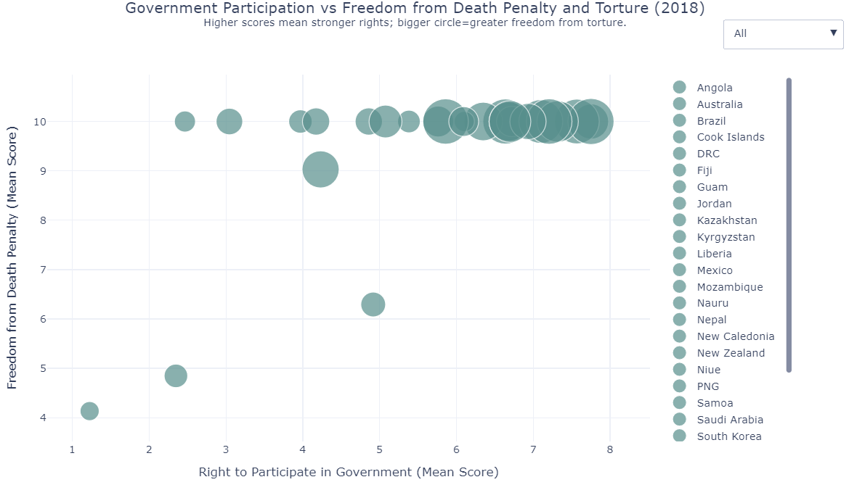

## Question 2: (2018 only) Compare various countries’ rights to form unions and their rights to favourable work conditions. **jobcond and union in HRMI People at Risk (PaR) Dataset.**

* Higher proportion indicates a higher risk for that respective right to be compromised
* Pg 5,6, and 7 of codebook
* Variables used:
  + **year**: 2018
  + **country**
  + **jobcond:** Right to just and favourable work conditions
  + **union:** Rights to form and join unions to go on strikes
* Groups I looked at (3 subplots and 1 large plot, dropdown menu to change between them)
  + Women
  + LGBTQIA+
  + Members of Labor Unions
    - Chose to look at the effect son members of labour unions because this could show signs of corrupt government, active suppression of efforts to improve working conditions, and the fact that union members fight for all people’s right to have a good working environment (not just their union members)
* Summary of findings: Based on our analysis of the 2018 data, our scatter plot visualizes the proportion of at-risk individuals for both job conditions and union rights across three distinct groups: women, LGBTQIA+ people, and union advocates. This plot highlights the countries where these groups face varying levels of risk, with a focus on the correlation between the two aspects. The "good zone," marked in light green, identifies countries that perform “well” in protecting both job conditions and union rights, with lower proportions indicating better conditions. Countries falling within this zone are those with a relatively lower risk of losing both job protections and union rights. The dropdown filter allows for an exploration of the data by each group, providing insights into how each group is represented across different countries. The use of distinct colors for each group (purple for women, teal for LGBTQIA+, and crimson for union advocates) enhances the visual clarity, making it easier to interpret the findings and compare risks among groups.
* Remember: For my interactive plot, we also *have* to submit the html file for the figure so that she can actually view the graph when we submit it to github. The file should be called “Question2.html”

**Code:**

**# Load your data**

**PaR = pd.read_csv('people_at_risk.csv')**

**# Grouped data**

**PaR_2018 = PaR[PaR['year'] == 2018]**

**# Select only needed columns**

**columns_of_interest = ['country',**

**'jobcond_atrisk_prop10', 'union_atrisk_prop10',**

**'jobcond_atrisk_prop11', 'union_atrisk_prop11',**

**'jobcond_atrisk_prop19', 'union_atrisk_prop19']**

**# Narrow down and clean**

**PaR_subset = PaR_2018[columns_of_interest].dropna()**

**# Rename columns**

**PaR_focus = PaR_subset.rename(columns={**

**'jobcond_atrisk_prop10': 'jobcond_women_proportion',**

**'union_atrisk_prop10': 'union_women_proportion',**

**'jobcond_atrisk_prop11': 'jobcond_lgbtq_proportion',**

**'union_atrisk_prop11': 'union_lgbtq_proportion',**

**'jobcond_atrisk_prop19': 'jobcond_unions_proportion',**

**'union_atrisk_prop19': 'union_unions_proportion'**

**})**

**# Groups and labels**

**groups = ['women', 'lgbtq', 'unions']**

**group_labels = {**

**'women': 'Women and/or Girls',**

**'lgbtq': 'LGBTQIA+ People',**

**'unions': 'Union Advocates'**

**}**

**# Define distinct colors**

**colors = {**

**'women': 'purple', # Purple**

**'lgbtq': 'cyan', # Teal**

**'unions': 'red' # Red**

**}**

**# Create the figure**

**fig = go.Figure()**

**# Add traces for each group**

**for group in groups:**

**fig.add_trace(go.Scatter(**

**x=PaR_focus[f'jobcond_{group}_proportion'],**

**y=PaR_focus[f'union_{group}_proportion'],**

**mode='markers',**

**marker=dict(color=colors[group], size=10, line=dict(width=1, color='black')),**

**text=PaR_focus['country'],**

**hovertemplate=(**

**'<b>%{text}</b><br>' +**

**'Work Conditions At-Risk (Proportion): %{x:.2f}<br>' +**

**'Union Rights At-Risk (Proportion): %{y:.2f}<extra></extra>'**

**),**

**name=group_labels[group],**

**visible=True**

**))**

**# Dropdown buttons**

**dropdown_buttons = [**

**dict(label="All",**

**method="update",**

**args=[{"visible": [True] * len(groups)},**

**{"title": "At-Risk: Job Conditions vs Union Rights by Group (2018)"}])**

**]**

**for i, group in enumerate(groups):**

**visibility = [j == i for j in range(len(groups))]**

**dropdown_buttons.append(**

**dict(label=group_labels[group],**

**method="update",**

**args=[{"visible": visibility},**

**{"title": f"At-Risk: {group_labels[group]} - Work Conditions vs Union Rights (2018)"}])**

**)**

**# Update the layout**

**fig.update_layout(**

**updatemenus=[**

**dict(**

**active=0,**

**buttons=dropdown_buttons,**

**direction="down",**

**x=1.15,**

**xanchor="left",**

**y=1.1,**

**yanchor="top"**

**)**

**],**

**title="At-Risk: Work Conditions vs Union Rights by Group (2018)",**

**template="plotly_white",**

**height=600,**

**width=1200,**

**xaxis=dict(**

**title="At Risk: Right to Fair and Just Work Conditions (Proportion)",**

**range=[-0.05, 0.8]**

**),**

**yaxis=dict(**

**title="At Risk: Right to Union (Proportion)",**

**range=[-0.05, 0.7]**

**),**

**shapes=[**

**dict(**

**type="rect",**

**x0=0, y0=0,**

**x1=0.2, y1=0.2, # You can adjust this to whatever "good" looks like**

**fillcolor="lightgreen",**

**opacity=0.3,**

**layer="below",**

**line_width=0**

**)**

**],**

**)**

**# TRENDS**

**# Further up and to the right is bad**

**# Further down and to the left is good**

**# Green zone highlights countries that are doing well in terms of protecting these rights. Countries with all 3 groups in the green box are doing great!**

**# Save and show**

**fig.write_html("figures/with_dropdown_filter.html")**

**fig.show()**

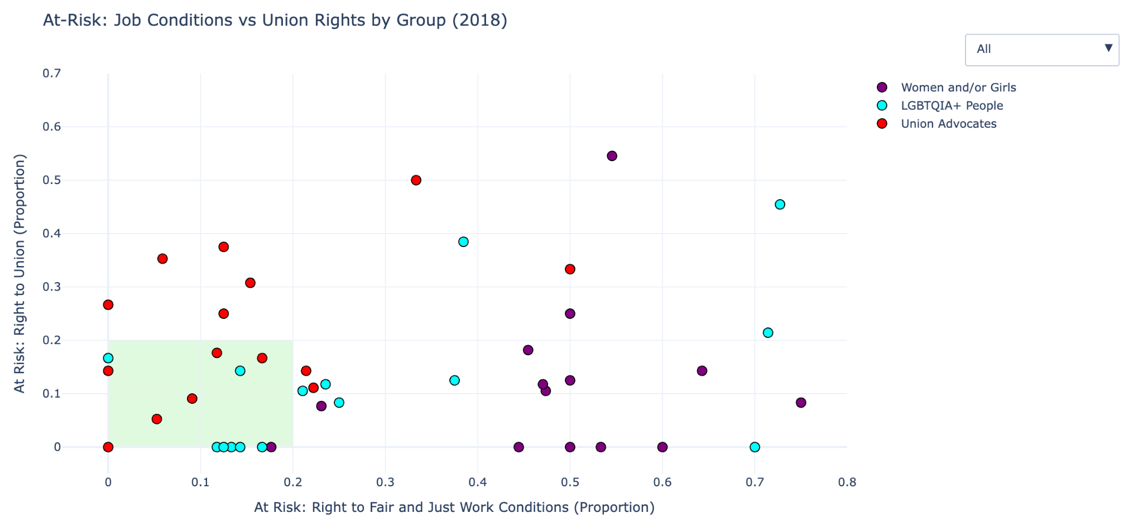

## Question 3: Compare various countries’ right to assembly and association, such as with protest groups or unions (**assem)** and right to opinion and expression, such as right to free speech (**express)** to their overall right to safety from the state, described in detail below (**physint),** in **HRMI Civil and Political Rights (CPR) Dataset**

* Numbers mean “intensity of respect for that right”
* Pg 4 of Codebook: <https://www.dropbox.com/scl/fi/erkmpbo2zuwc2y46e85nl/HRMI_Data_Download_2024_release.zip?dl=0&e=1&file_subpath=%2FHRMI_Data_Download_2024_release%2FHRMI_Data_Download_2024.6.20%2FHRMI+dataset+codebook+2024.6.20.pdf&rlkey=oyo7qw9kvxi12he2hmmx6qwvv>
* Variables Used:
  + **year** (2018)
  + **country**
  + **physint** - Overall right to safety from the state, i.e. Physical Integrity Rights - Based on scores for arrest, disap, dpex, exkill, and tort
    - arrest - Right to freedom from arbitrary or political arrest and imprisonment
    - disap - Right to freedom from disappearance
    - dpex - Right to freedom from death penalty execution
    - exkill - Right to freedom from extrajudicial execution
    - tort - Right to freedom from torture and ill - treatment
  + **assem** - Right to assembly and association
  + **express** - Right to opinion and expression
* Plots with 3-layers(x axis = **assem_mean/lo/hi**, y axis = **express_mean/lo/hi**, size of dot = **physint_mean/lo/hi** ):
  + **"right"_mean** - average intensity score (purple)
  + **"right"_lo** - 10th percentile (red)
  + **"right"_hi** - 90th percentile (green)
* Results:
  + positive correlation found between the right to assembly and the right to expression
  + Makes sense because both of these^ are related to overall right to empowerment
  + Can also see dot SIZES increasing in a positive correlation to **physint**, suggesting that right to empowerment and safety from the state are positively related around the world

Q3: Olivia

*# Import necessary libraries*

import **pandas** as **pd** *# For non-plot commands*

import **matplotlib**.**pyplot** as **plt** *# For non-interactive plots*

import **plotly**.**graph_objects** as **go** *# For interactive plots*

*# Import necessary data*

*cpr =* ***pd****.****read_csv****("csv files/cpr.csv") # CPR stands for Civil and Political Rights*

*# Check column names*

***print****(cpr.columns)*

*# See the df*

*cpr.****head****()*

*# Clean df to take data from only 2018*

*cpr_2018 = cpr[cpr['year']* ***==*** *2018]*

*# See the new df*

*cpr_2018.****head****()*

*# Further clean dataset to only include relevant data from Q3: Compare various countries’ assem to physint*

*cpr_2018_q3 = cpr_2018[['country', 'year', 'assem_mean', 'assem_sd', 'assem_lo', 'assem_hi', 'express_mean', 'express_sd', 'express_lo', 'express_hi', 'physint_mean', 'physint_sd', 'physint_lo', 'physint_hi']]*

*# Check if it worked*

***print****(cpr_2018_q3.columns)*

*# See the df*

*cpr_2018_q3*

*# Remove any rows with missing values for any column*

*cpr_final = cpr_2018_q3.****dropna****()*

***print****(cpr_final.columns)*

*# See the df*

*cpr_final*

*# Make a scatterplot to compare various countries in 2018*

***plt****.****style****.****use****('fivethirtyeight')*

***plt****.****figure****(figsize=(15, 9))*

***plt****.****scatter****(x=cpr_final["assem_mean"], y=cpr_final["express_mean"], s=cpr_final["physint_mean"]****\*****100, color='purple', alpha=0.5, label='Average Intensity Score')*

***plt****.****scatter****(x=cpr_final["assem_lo"], y=cpr_final["express_lo"], s=cpr_final["physint_lo"]****\*****100, color='red', alpha=0.5, label='10th Percentile')*

***plt****.****scatter****(x=cpr_final["assem_hi"], y=cpr_final["express_hi"], s=cpr_final["physint_hi"]****\*****100, color='green', alpha=0.5, label='90th Percentile')*

*# Need to scale up the sizes of the dots so that noticable size differences can actually be seen*

***plt****.****xlabel****("Right to Assembly and Association")*

***plt****.****ylabel****("Right to Opinion and Expression")*

***plt****.****legend****(loc='upper left', bbox_to_anchor=(1, 1))*

***plt****.****title****("Rights to Assembly and Freedom of Expression Compared to Physical Integrity Rights in Various Countries in 2018")*

***plt****.****show****()*

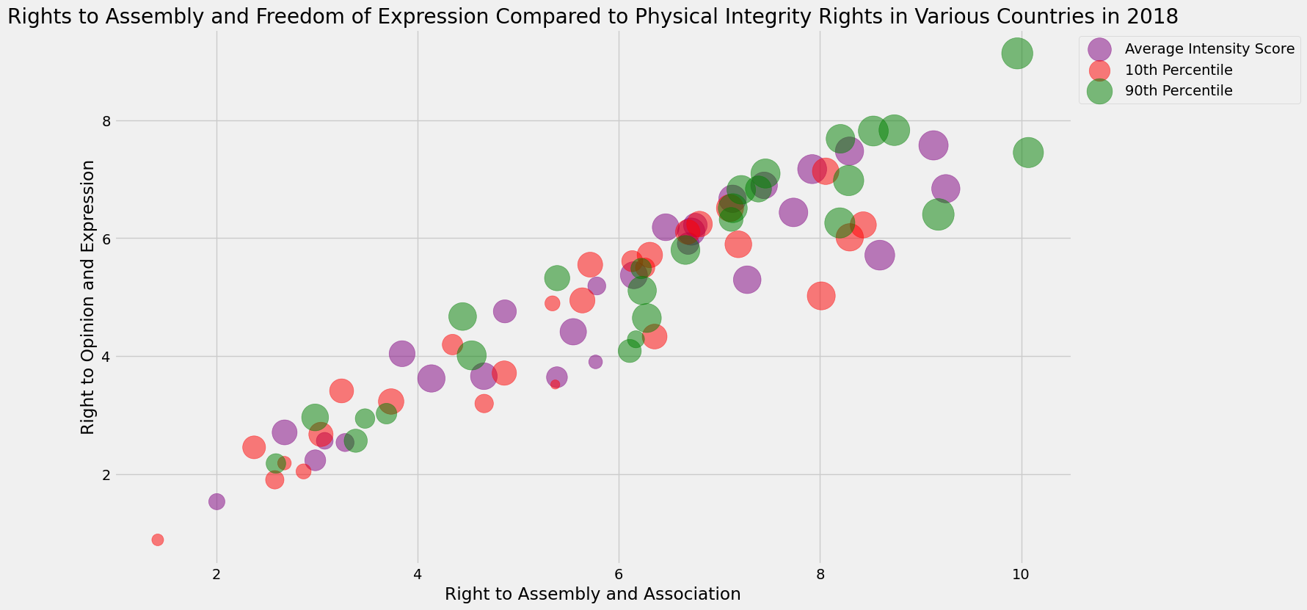

*# Create an interactive plot as well*

*fig =* ***go****.****Figure****()*

*# Add "right"_mean data*

*fig.****add_trace****(****go****.****Scatter****(*

*x=cpr_final["assem_mean"],*

*y=cpr_final["express_mean"],*

*mode='markers',*

*marker=****dict****(*

*size=cpr_final["physint_mean"]* ***\**** *5, # adjust scaling*

*color='purple',*

*opacity=0.5,*

*),*

*name='Average Intensity Score',*

*text="Country: "+cpr_final["country"], # hover text showing country name*

*hoverinfo='text+x+y',*

*hovertemplate=(*

*"Average Score for Right to Assembly and Association: %{x}<br>" +*

*"Average Score for Right to Opinion and Expression: %{y}<br>" +*

*"Country: "+cpr_final["country"]****+***

*"<extra></extra>" # <extra></extra> removes the secondary hover box*

*)))*

*# Add "right"_lo (10th percentile) data*

*fig.****add_trace****(****go****.****Scatter****(*

*x=cpr_final["assem_lo"],*

*y=cpr_final["express_lo"],*

*mode='markers',*

*marker=****dict****(*

*size=cpr_final["physint_lo"]* ***\**** *5,*

*color='red',*

*opacity=0.5,*

*),*

*name='10th Percentile',*

*text="Country: "+cpr_final["country"],*

*hoverinfo='text+x+y',*

*hovertemplate=(*

*"Bottom 10% Score for Right to Assembly and Association: %{x}<br>" +*

*"Bottom 10% Score for Right to Opinion and Expression: %{y}<br>" +*

*"Country: "+cpr_final["country"]****+***

*"<extra></extra>" # <extra></extra> removes the secondary hover box*

*)))*

*# Add "right"_hi (90th percentile) dots*

*fig.****add_trace****(****go****.****Scatter****(*

*x=cpr_final["assem_hi"],*

*y=cpr_final["express_hi"],*

*mode='markers',*

*marker=****dict****(*

*size=cpr_final["physint_hi"]* ***\**** *5,*

*color='green',*

*opacity=0.5,*

*),*

*name='90th Percentile',*

*text="Country: "+cpr_final["country"],*

*hoverinfo='text+x+y',*

*hovertemplate=(*

*"Top 10% Score for Right to Assembly and Association: %{x}<br>" +*

*"Top 10% Score for Right to Opinion and Expression: %{y}<br>" +*

*"Country: "+cpr_final["country"]****+***

*"<extra></extra>" # <extra></extra> removes the secondary hover box*

*)*

*))*

*# Customize the layout*

*fig.****update_layout****(*

*title="Score for Empowerment to the Overall Right to Safety from the State in Various Countries in 2018",*

*xaxis_title="Right to Assembly and Association",*

*yaxis_title="Right to Opinion and Expression",*

*legend_title='Intensity of Respect Dataset',*

*legend=****dict****(x=1.05, y=1),*

*width=1000,*

*height=600,*

*template='plotly_white'*

*)*

*# Check the plot*

*fig.****write_html****("csv files/q3.html")*

*fig.****show****()*

Analysis of all the code

**Question 1: Analyzing Civil and Political Rights Across Countries**

The code examines the relationship between the right to participate in government, freedom from death penalty execution, and freedom from torture across different countries in 2018.

**Data Preparation**

python

import pandas as pd

import matplotlib.pyplot as plt

import plotly.graph_objects as go

These lines import the necessary libraries: pandas for data handling, matplotlib for basic plotting capabilities, and plotly for creating interactive visualizations.

python

cprq1 = pd.read_csv("C:/Users/Daisy/OneDrive - Emory/Desktop/QTM 151/HRMI_Data_Download_2024_release/HRMI_Data_Download_2024.6.20/csv files/cpr.csv")

print(cprq1.columns)

cprq1.head()

Here, the code loads the Civil and Political Rights dataset, prints all column names to understand what data is available, and shows the first few rows to inspect the data.

python

cpr_2018 = cprq1[cprq1['year'] == 2018]

cpr_2018.head()

This filters the dataset to include only data from 2018, which is the focus year of the study.

python

columns_of_interest = ['country', 'year', 'polpart_mean', 'polpart_sd', 'polpart_lo', 'polpart_hi',

'dpex_mean', 'dpex_sd', 'dpex_lo', 'dpex_hi',

'tort_mean', 'tort_sd', 'tort_lo', 'tort_hi']

cpr_q1_2018_filtered = cpr_2018[columns_of_interest]

cpr_q1_2018_filtered.head()

cpr_q1_2018_filtered

These lines select only the relevant columns for the analysis: country identification, political participation metrics, death penalty execution metrics, and torture metrics. Each metric includes mean values, standard deviations, and percentile bounds.

**Option 1: Interactive Plot with Torture Color Gradient**

python

fig = go.Figure()

fig.add_trace(go.Scatter(

x=cpr_q1_2018_filtered["polpart_mean"],

y=cpr_q1_2018_filtered["dpex_mean"],

mode='markers',

text=cpr_q1_2018_filtered['country'],

marker=dict(

size=cpr_q1_2018_filtered['tort_mean'] * 7,

color=cpr_q1_2018_filtered['tort_mean'],

colorscale='Viridis',

showscale=True,

colorbar=dict(

title='Mean Torture Level',

titleside='right',

tickvals=[cpr_q1_2018_filtered['tort_mean'].min(),

cpr_q1_2018_filtered['tort_mean'].max()],

ticktext=['Low', 'High']

),

opacity=0.6

),

hovertemplate='<b>Country:</b> %{text}<br>' +

'<b>Right to Participate in Government:</b> %{x}<br>' +

'<b>Freedom from Death Penalty:</b> %{y}<br>' +

'<b>Mean Torture Score:</b> %{marker.color}<extra></extra>'

))

This code creates an interactive scatter plot where:

* Each point represents a country
* X-axis shows the mean score for right to participate in government
* Y-axis shows the mean score for freedom from death penalty execution
* The size of each point is proportional to the country's mean torture score (multiplied by 7 to make differences more visible)
* The color of each point represents the torture score using a purple-to-green gradient (Viridis colorscale)
* When hovering over a point, information about the country, its political participation score, death penalty freedom score, and torture score appear
* The opacity is set to 0.6 to help see overlapping points

python

fig.update_layout(

title={

'text': 'Government Participation vs Freedom from Death Penalty and Torture (2018)<br><sup>Higher x-values mean stronger rights; Higher y-values mean stronger freedom from death penalty<br><sup> Lighter color indicates higher torture mean score',

'y':0.95,

'x':0.5,

'xanchor': 'center',

'yanchor': 'top'

},

xaxis=dict(

title='Right to Participate in Government (Mean Score)',

title_font=dict(size=18),

tickfont=dict(size=12)

),

yaxis=dict(

title='Freedom from Death Penalty (Mean Score)',

title_font=dict(size=16),

tickfont=dict(size=12)

),

width=1000,

height=600,

template='plotly_white'

)

This customizes the plot appearance with:

* A descriptive title explaining how to interpret the visualization
* Clear axis labels with appropriate font sizes
* A clean white background template
* Set dimensions for the plot (1000×600 pixels)

python

fig.write_html("C:/Users/Daisy/OneDrive - Emory/Desktop/QTM 151/HRMI_Data_Download_2024_release/HRMI_Data_Download_2024.6.20/csv files/cpr_interactive_plot.html")

fig.show()

The plot is saved as an HTML file (which allows for interactivity when opened in a browser) and displayed in the current environment.

**Option 2: Interactive Scatterplot with Country Selection**

python

countries = sorted(cpr_q1_2018_filtered['country'].unique())

This creates a sorted list of all unique country names in the dataset.

python

fig = go.Figure()

for country in countries:

df_subset = cpr_q1_2018_filtered[cpr_q1_2018_filtered['country'] == country]

fig.add_trace(go.Scatter(

x=df_subset["polpart_mean"],

y=df_subset["dpex_mean"],

mode='markers',

name=country,

text=df_subset['country'],

marker=dict(

size=df_subset['tort_mean'] * 7,

color=df_subset['tort_mean'],

colorscale='Viridis',

showscale=False,

opacity=0.7

),

visible=True

))

This code:

* Creates a new figure
* For each country in the dataset, adds a separate scatter trace
* Each country's trace uses the same variables as Option 1 (political participation vs death penalty freedom)
* The marker size and color are again based on torture scores
* The individual color scales are turned off (showscale=False) to avoid multiple legends
* All country traces are initially visible (visible=True)

python

dropdown_buttons = [

dict(label="All",

method="update",

args=[{"visible": [True] * len(countries)},

{"title": "Government Participation vs Freedom from Death Penalty and Torture (2018)"}])

]

for i, country in enumerate(countries):

visibility = [j == i for j in range(len(countries))]

dropdown_buttons.append(

dict(label=country,

method="update",

args=[{"visible": visibility},

{"title": f"{country}: Participation vs Death Penalty Freedom"}])

)

This creates a dropdown menu with:

* An "All" option that shows all countries
* Individual options for each country that hide all other countries when selected
* Custom titles that update based on the selection

python

fig.update_layout(

updatemenus=[

dict(

active=0,

buttons=dropdown_buttons,

direction="down",

x=1.12,

xanchor="left",

y=1.15,

yanchor="top"

)

],

title={

'text': 'Government Participation vs Freedom from Death Penalty and Torture (2018)<br><sup>Higher scores mean stronger rights; bigger circle=greater freedom from torture.</sup>',

'y':0.95,

'x':0.5,

'xanchor': 'center',

'yanchor': 'top'

},

xaxis_title="Right to Participate in Government (Mean Score)",

yaxis_title="Freedom from Death Penalty (Mean Score)",

xaxis_tickangle=0,

width=1000,

height=600,

template="plotly_white"

)

This positions the dropdown menu and configures the plot appearance similar to Option 1.

python

fig.update_layout(

coloraxis_colorbar=dict(

title='Mean Torture Level',

tickvals=[cpr_q1_2018_filtered['tort_mean'].min(), cpr_q1_2018_filtered['tort_mean'].max()],

ticktext=['Low', 'High']

)

)

This adds a global color bar that explains the color scale for torture levels across all countries.

python

fig.show()

Finally, the interactive plot with country selection is displayed.

The key difference between the two visualization options is that Option 1 displays all countries in a single view with a built-in color legend for torture scores, while Option 2 adds the ability to filter the view to focus on individual countries, making it easier to analyze specific nations of interest.

### **Analysis of Results**

#### **Relationship Between Political Participation and Death Penalty**

The scatter plot reveals important patterns in how these rights correlate across countries:

* **Democratic Countries**: Nations in the upper-right quadrant demonstrate strong respect for both political participation and freedom from death penalty execution. These typically represent established democracies where citizens have meaningful political agency and where the death penalty has been abolished or is rarely used.
* **Authoritarian States with Death Penalty**: Countries in the lower-left quadrant show limited political participation rights alongside continued use of the death penalty. This pattern reflects authoritarian governments that restrict political freedoms and maintain harsh punishment systems.
* **Mixed Rights Countries**: Some countries appear in the upper-left (strong death penalty protections but limited political participation) or lower-right (strong political participation but continued death penalty use). These outliers challenge the assumption that these rights necessarily develop together.

#### **Torture as a Third Dimension**

The visualization's use of point size/color to represent torture scores adds critical insight:

* **Rights Consistency**: Countries with large, bright points in the upper-right quadrant demonstrate consistent protection across all three rights dimensions, suggesting comprehensive human rights frameworks.
* **Torture as a Lagging Right**: If some countries in the upper-right (strong on political participation and death penalty) have smaller or darker points, it suggests torture protections may lag behind other political rights reforms.
* **Regional Patterns**: The clustering of similarly sized/colored points may reveal regional patterns in torture practices independent of other political rights

**Analysis of Question 2: At-Risk Groups' Rights to Work Conditions and Unions**

**Question 2: Comparing Job Conditions and Union Rights for At-Risk Groups**

This code examines how different vulnerable populations' rights to favorable working conditions and union formation vary across countries in 2018.

**Data Preparation**

python

*# Load your data*

PaR = pd.read_csv('people_at_risk.csv')

This loads the "People at Risk" dataset that contains information about vulnerable groups and their risk levels for different rights violations.

python

*# Grouped data*

PaR_2018 = PaR[PaR['year'] == 2018]

The dataset is filtered to include only data from 2018, consistent with the study's focus year.

python

*# Select only needed columns*

columns_of_interest = ['country',

'jobcond_atrisk_prop10', 'union_atrisk_prop10',

'jobcond_atrisk_prop11', 'union_atrisk_prop11',

'jobcond_atrisk_prop19', 'union_atrisk_prop19']

This selects only the relevant columns for analysis:

* country identification
* Proportion at risk for job conditions and union rights for women (prop10)
* Proportion at risk for job conditions and union rights for LGBTQIA+ people (prop11)
* Proportion at risk for job conditions and union rights for union members/advocates (prop19)

python

*# Narrow down and clean*

PaR_subset = PaR_2018[columns_of_interest].dropna()

This creates a subset with only the selected columns and removes any rows with missing values to ensure complete data.

python

*# Rename columns*

PaR_focus = PaR_subset.rename(columns={

'jobcond_atrisk_prop10': 'jobcond_women_proportion',

'union_atrisk_prop10': 'union_women_proportion',

'jobcond_atrisk_prop11': 'jobcond_lgbtq_proportion',

'union_atrisk_prop11': 'union_lgbtq_proportion',

'jobcond_atrisk_prop19': 'jobcond_unions_proportion',

'union_atrisk_prop19': 'union_unions_proportion'

})

This renames the columns to more descriptive names, making the code more readable and clearly identifying which population each column refers to.

**Setting Up Groups and Visual Elements**

python

*# Groups and labels*

groups = ['women', 'lgbtq', 'unions']

group_labels = {

'women': 'Women and/or Girls',

'lgbtq': 'LGBTQIA+ People',

'unions': 'Union Advocates'

}

This defines the three groups being analyzed and provides descriptive labels for display in the visualization.

python

*# Define distinct colors*

colors = {

'women': 'purple', *# Purple*

'lgbtq': 'cyan', *# Teal/Cyan*

'unions': 'red' *# Red*

}

This assigns a distinct color to each group for visual differentiation in the plot.

**Creating the Interactive Visualization**

python

*# Create the figure*

fig = go.Figure()

This initializes a new Plotly figure object for the interactive visualization.

python

*# Add traces for each group*

for group in groups:

fig.add_trace(go.Scatter(

x=PaR_focus[f'jobcond_{group}_proportion'],

y=PaR_focus[f'union_{group}_proportion'],

mode='markers',

marker=dict(color=colors[group], size=10, line=dict(width=1, color='black')),

text=PaR_focus['country'],

hovertemplate=(

'<b>%{text}</b><br>' +

'Work Conditions At-Risk (Proportion): %{x:.2f}<br>' +

'Union Rights At-Risk (Proportion): %{y:.2f}<extra></extra>'

),

name=group_labels[group],

visible=True

))

This code creates a scatter plot trace for each of the three groups:

* X-axis shows the proportion of people at risk for job conditions for that group
* Y-axis shows the proportion of people at risk for union rights for that group
* Each point represents a country
* Points are colored according to the group (purple for women, cyan for LGBTQIA+, red for union advocates)
* Each point has a black border for better visibility
* Hover template shows country name and exact proportions formatted to 2 decimal places
* All three groups are initially visible

python

*# Dropdown buttons*

dropdown_buttons = [

dict(label="All",

method="update",

args=[{"visible": [True] * len(groups)},

{"title": "At-Risk: Job Conditions vs Union Rights by Group (2018)"}])

]

This creates the first dropdown button option to show all groups together.

python

for i, group in enumerate(groups):

visibility = [j == i for j in range(len(groups))]

dropdown_buttons.append(

dict(label=group_labels[group],

method="update",

args=[{"visible": visibility},

{"title": f"At-Risk: {group_labels[group]} - Work Conditions vs Union Rights (2018)"}])

)

This adds a button for each group that, when selected:

* Makes only that group's trace visible
* Updates the title to reflect the selected group

**Finalizing the Plot Layout**

python

*# Update the layout*

fig.update_layout(

updatemenus=[

dict(

active=0,

buttons=dropdown_buttons,

direction="down",

x=1.15,

xanchor="left",

y=1.1,

yanchor="top"

)

],

title="At-Risk: Work Conditions vs Union Rights by Group (2018)",

template="plotly_white",

height=600,

width=1200,

xaxis=dict(

title="At Risk: Right to Fair and Just Work Conditions (Proportion)",

range=[-0.05, 0.8]

),

yaxis=dict(

title="At Risk: Right to Union (Proportion)",

range=[-0.05, 0.7]

),

shapes=[

dict(

type="rect",

x0=0, y0=0,

x1=0.2, y1=0.2, *# You can adjust this to whatever "good" looks like*

fillcolor="lightgreen",

opacity=0.3,

layer="below",

line_width=0

)

],

)

This customizes the plot appearance with:

* A dropdown menu positioned at the top right
* A clear title
* A clean white background template
* Set dimensions for the plot (1200×600 pixels)
* Labeled axes with fixed ranges to ensure consistent scale across different selections
* A light green rectangle highlighting the "good zone" (low risk area) where countries have better protection of both rights (lower proportions indicate lower risk)

python

*# Save and show*

fig.write_html("figures/with_dropdown_filter.html")

fig.show()

The interactive plot is saved as an HTML file (which preserves interactivity) and displayed in the current environment.

This visualization allows for analysis of how different vulnerable groups (women, LGBTQIA+ people, and union advocates) experience risks to their job conditions and union rights across various countries. The green "good zone" highlights countries with lower proportions at risk for both rights, indicating better protection. The dropdown filter enables easy comparison between groups.

### **Analysis of Results**

#### **Workplace Rights Correlations**

The scatter plot reveals whether protections for working conditions correlate with union formation rights:

* **Strong Correlation**: If points generally follow a diagonal pattern (bottom-left to top-right), it suggests countries that protect favorable working conditions also tend to protect union rights. This would indicate these labor rights typically co-develop.
* **Working Conditions Without Unions**: Countries in the bottom-right quadrant protect basic working conditions while restricting union formation, potentially representing paternalistic labor systems where conditions are regulated but worker organizing is limited.
* **Unions Without Conditions Protections**: Countries in the top-left quadrant allow union formation but have poor working conditions protections, suggesting formal rights without substantive enforcement.

#### **Vulnerable Group Disparities**

The color-coded points reveal critical patterns in how workplace rights vary by vulnerable group:

* **Systematic Disadvantage**: If one color consistently appears higher on both axes than others, it indicates that a particular group faces systematically higher workplace discrimination across countries.
* **Right-Specific Vulnerabilities**: If certain groups cluster higher on one axis but not the other, it suggests specific types of workplace discrimination (e.g., women might face more working conditions issues while LGBTQIA+ people face more union restrictions).
* **Union Advocate Paradox**: If union advocates themselves show high risk for both metrics, it demonstrates a structural barrier where those who would advocate for better conditions face the greatest opposition.

#### **Policy and Advocacy Implications**

For labor organizations and human rights advocates, the visualization demonstrates:

1. **Targeted Protection Strategies**: Evidence for whether unified labor policies can protect all vulnerable groups or if group-specific protections are necessary.
2. **Union-Condition Relationship**: Understanding whether strengthening union rights tends to improve working conditions or whether these require separate policy approaches.
3. **Most Vulnerable Identification**: The visualization clearly identifies which groups face the highest workplace risks in which countries, allowing for prioritized intervention.

**Analysis of Question 3: Assembly, Expression, and State Safety Rights**

**Question 3: Comparing Rights to Assembly and Expression with Physical Integrity Rights**

This code examines the relationship between rights to assembly/association, opinion/expression, and physical integrity (safety from the state) across countries in 2018.

**Data Preparation**

python

*# Import necessary libraries*

import pandas as pd *# For non-plot commands*

import matplotlib.pyplot as plt *# For non-interactive plots*

import plotly.graph_objects as go *# For interactive plots*

These lines import the necessary libraries for data manipulation and both static and interactive visualizations.

python

*# Import necessary data*

cpr = pd.read_csv("csv files/cpr.csv") *# CPR stands for Civil and Political Rights*

*# Check column names*

print(cpr.columns)

*# See the df*

cpr.head()

This loads the Civil and Political Rights dataset, prints all column names to understand the data structure, and displays the first few rows for inspection.

python

*# Clean df to take data from only 2018*

cpr_2018 = cpr[cpr['year'] == 2018]

*# See the new df*

cpr_2018.head()

The dataset is filtered to include only data from 2018, consistent with the study's focus year.

python

*# Further clean dataset to only include relevant data from Q3: Compare various countries' assem to physint*

cpr_2018_q3 = cpr_2018[['country', 'year', 'assem_mean', 'assem_sd', 'assem_lo', 'assem_hi', 'express_mean', 'express_sd', 'express_lo', 'express_hi', 'physint_mean', 'physint_sd', 'physint_lo', 'physint_hi']]

*# Check if it worked*

print(cpr_2018_q3.columns)

*# See the df*

cpr_2018_q3

This creates a subset with only the columns relevant to Question 3:

* country and year for identification
* assembly/association rights metrics (assem_*)
* opinion/expression rights metrics (express_*)
* physical integrity (safety from state) metrics (physint_*) Each metric includes mean scores, standard deviations, and percentile bounds (lo = 10th percentile, hi = 90th percentile).

python

*# Remove any rows with missing values for any column*

cpr_final = cpr_2018_q3.dropna()

print(cpr_final.columns)

*# See the df*

cpr_final

This removes any rows with missing values to ensure complete data for all countries included in the analysis.

**Creating a Static Visualization**

python

*# Make a scatterplot to compare various countries in 2018*

plt.style.use('fivethirtyeight')

plt.figure(figsize=(15, 9))

plt.scatter(x=cpr_final["assem_mean"], y=cpr_final["express_mean"], s=cpr_final["physint_mean"]*100, color='purple', alpha=0.5, label='Average Intensity Score')

plt.scatter(x=cpr_final["assem_lo"], y=cpr_final["express_lo"], s=cpr_final["physint_lo"]*100, color='red', alpha=0.5, label='10th Percentile')

plt.scatter(x=cpr_final["assem_hi"], y=cpr_final["express_hi"], s=cpr_final["physint_hi"]*100, color='green', alpha=0.5, label='90th Percentile')

This creates a static scatterplot with three different datasets (layers):

1. Purple points: Mean scores for assembly rights vs. expression rights, with point size based on mean physical integrity
2. Red points: 10th percentile scores for both rights, with point size based on 10th percentile physical integrity
3. Green points: 90th percentile scores for both rights, with point size based on 90th percentile physical integrity

Point sizes are multiplied by 100 to make differences more visible. The alpha (transparency) is set to 0.5 to help see overlapping points.

python

plt.xlabel("Right to Assembly and Association")

plt.ylabel("Right to Opinion and Expression")

plt.legend(loc='upper left', bbox_to_anchor=(1, 1))

plt.title("Rights to Assembly and Freedom of Expression Compared to Physical Integrity Rights in Various Countries in 2018")

plt.show()

This adds axis labels, a legend positioned to the right of the plot, a descriptive title, and displays the static plot.

**Creating an Interactive Visualization**

python

*# Create an interactive plot as well*

fig = go.Figure()

This initializes a new Plotly figure for the interactive visualization.

python

*# Add "right"_mean data*

fig.add_trace(go.Scatter(

x=cpr_final["assem_mean"],

y=cpr_final["express_mean"],

mode='markers',

marker=dict(

size=cpr_final["physint_mean"] * 5, *# adjust scaling*

color='purple',

opacity=0.5,

),

name='Average Intensity Score',

text="Country: "+cpr_final["country"], *# hover text showing country name*

hoverinfo='text+x+y',

hovertemplate=(

"Average Score for Right to Assembly and Association: %{x}<br>" +

"Average Score for Right to Opinion and Expression: %{y}<br>" +

"Country: "+cpr_final["country"]+

"<extra></extra>" *# <extra></extra> removes the secondary hover box*

)))

This adds the first trace showing mean scores for each country with:

* X-axis showing mean scores for right to assembly/association
* Y-axis showing mean scores for right to opinion/expression
* Purple markers with size proportional to mean physical integrity scores
* Custom hover template showing detailed information including country name

python

*# Add "right"_lo (10th percentile) data*

fig.add_trace(go.Scatter(

x=cpr_final["assem_lo"],

y=cpr_final["express_lo"],

mode='markers',

marker=dict(

size=cpr_final["physint_lo"] * 5,

color='red',

opacity=0.5,

),

name='10th Percentile',

text="Country: "+cpr_final["country"],

hoverinfo='text+x+y',

hovertemplate=(

"Bottom 10% Score for Right to Assembly and Association: %{x}<br>" +

"Bottom 10% Score for Right to Opinion and Expression: %{y}<br>" +

"Country: "+cpr_final["country"]+

"<extra></extra>" *# <extra></extra> removes the secondary hover box*

)))

This adds the second trace showing 10th percentile scores (lower bounds) with:

* Same axes but using the 10th percentile values
* Red markers with size proportional to 10th percentile physical integrity scores
* Custom hover template showing this represents the "Bottom 10%" scores

python

*# Add "right"_hi (90th percentile) dots*

fig.add_trace(go.Scatter(

x=cpr_final["assem_hi"],

y=cpr_final["express_hi"],

mode='markers',

marker=dict(

size=cpr_final["physint_hi"] * 5,

color='green',

opacity=0.5,

),

name='90th Percentile',

text="Country: "+cpr_final["country"],

hoverinfo='text+x+y',

hovertemplate=(

"Top 10% Score for Right to Assembly and Association: %{x}<br>" +

"Top 10% Score for Right to Opinion and Expression: %{y}<br>" +

"Country: "+cpr_final["country"]+

"<extra></extra>" *# <extra></extra> removes the secondary hover box*

)

))

This adds the third trace showing 90th percentile scores (upper bounds) with:

* Same axes but using the 90th percentile values
* Green markers with size proportional to 90th percentile physical integrity scores
* Custom hover template showing this represents the "Top 10%" scores

python

*# Customize the layout*

fig.update_layout(

title="Score for Empowerment to the Overall Right to Safety from the State in Various Countries in 2018",

xaxis_title="Right to Assembly and Association",

yaxis_title="Right to Opinion and Expression",

legend_title='Intensity of Respect Dataset',

legend=dict(x=1.05, y=1),

width=1000,

height=600,

template='plotly_white'

)

This customizes the plot appearance with:

* A descriptive title
* Clear axis labels
* A legend with a title positioned to the right of the plot
* Set dimensions for the plot (1000×600 pixels)
* A clean white background template

python

*# Check the plot*

fig.write_html("csv files/q3.html")

fig.show()

The interactive plot is saved as an HTML file and displayed in the current environment.

### **Key Implications**

This analysis of economic and social rights reveals:

* **Development Patterns**: Whether improvements in food security correlate with improvements in sanitation access, suggesting coordinated or divergent development paths.
* **Resource Allocation**: Evidence for whether countries can successfully advance multiple economic and social rights simultaneously or must prioritize certain rights.
* **Successful Models**: Countries showing strong improvement in both dimensions represent potential policy models for sustainable development.

For development organizations, this visualization provides guidance on whether these fundamental rights should be addressed through integrated programs or separate specialized interventions.